AI-Powered Digital Twin & Predictive Maintenance System

Intro and Literature of the Proposal:
This project introduces a low-cost, AI-powered digital twin platform tailored for MSMEs. Most small and medium enterprises in India use legacy machinery with no real-time fault detection or operational monitoring. By leveraging IoT sensors (vibration, temperature, current), this system enables data-driven predictive maintenance, minimizing unexpected breakdowns and maximizing productivity. Literature supports the effectiveness of digital twins and ML models in improving uptime and operational intelligence, especially when localized for resource-constrained settings.

Outcomes of Literature Review:
- Predictive maintenance improves machine uptime by 25-40%.
- Digital twins are widely adopted in large industries but rarely accessible for MSMEs.
- Low-cost sensors and open-source AI models make digital transformation feasible for small units.

Key Findings – In Terms of Problems:
- Unplanned breakdowns and production halts.
- No machine visibility or analytics in most MSMEs.
- High cost and complexity of commercial Industry 4.0 tools.

Key Findings – With Respect to Solutions:
- IoT retrofitting enables affordable machine monitoring.
- Predictive algorithms based on sensor data provide early fault alerts.
- Digital dashboards improve awareness and decision-making.

Time Period for Prototyping:
6-7 months for full MVP and pilot integration.

Revenue Requirement:
Estimated ₹3.5 lakhs for MVP including hardware, software, and pilot deployment.

Resources Available in Incubation Center:
- IoT development kits (Arduino, Raspberry Pi)
- Sensor modules (DHT11, MPU6050, current sensors)
- Software support: Python, ML libraries, FastAPI, Streamlit
- Mentorship for AI, product design, and field deployment

Working Group:
- AI/ML Developer
- Embedded Systems Engineer
- UI/UX Developer
- Pilot Deployment Lead

Problem Statement + Peer-to-Peer Integration:
Machines in MSMEs fail without warning. Our system integrates sensor data sharing across nearby MSMEs for collective learning and predictive improvement.

Market Opportunities:
Over 6.3 crore MSMEs in India, 80% of which lack digital diagnostics. Strong adoption potential in manufacturing, food processing, and engineering sectors.

Scale-Up Possibilities:
- SaaS dashboard subscriptions
- Plug-and-play hardware kits
- Regional support and training partners

Control circuit:
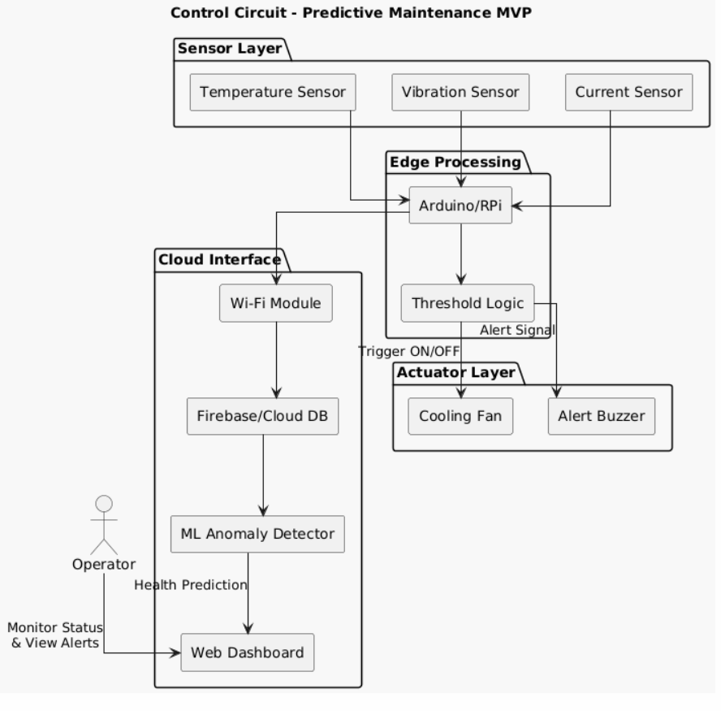

Components Required:
- Arduino Uno
- LCD Display (16x2)
- DHT11 Temp/Humidity Sensor
- Vibration/Current Sensor
- Raspberry Pi
- Power Adapter & Wiring
- Miscellaneous Components

S.No | Individual  Item |  | Cost per each Individual | Total Cost | Item Description
1 | Arduino |  | 2 | 1600 | Microcontroller for sensor data and control logic
2 | LCD Display (16x2) |  | 2 | 1500 | Displays sensor readings in real time
3 | DHT22 Temp/Humidity Sensor |  | 3 | 1050 | Accurate climate monitoring
4 | Vibration/Current Sensor |  | 2 | 3000 | Detects machine anomalies and power irregularities
5 | Raspberry Pi |  | 1 | 8000 | Runs ML model and dashboard interface
6 | Industrial Power Supply & UPS |  | 1 | 5000 | Uninterrupted power & surge protection
7 | 5V Relays + SSRs (industrial) |  | 4 | 1600 | Control actuators or fans safely
8 | Enclosure (IP-rated, metallic) |  | 1 | 4500 | Durable field deployment casing
9 | Development + Assembly Support |  | 1 | 10000 | Skilled help for circuit integration/testing
10 | Miscellaneous Components |  |  | 10000 | Spare Sensors, Connectors, Cloud Hosting, etc
Total |  |  |  | 50,000 | -

